**INCIDENT DETECTION**

Project Report v1

**May 10**

**Vehicle Detection:** [YOLO v2](https://arxiv.org/abs/1612.08242) Real Time Object Detection - One Shot Learning Algorithm

Official implementation [DarkNet](https://pjreddie.com/darknet/yolo/)

Converted packages into Keras using official [YAD2K](https://github.com/allanzelener/YAD2K) converter

Project Code in Python 3.6, Tensorflow and Keras

**Done**

* Detect almost all objects imaginable on roads ( Vehicles and Pedestrians )
* Draw bounding boxes over the detected objects
* Label the objects with their confidence scores
* Generate a new frame with the labels over the input frame

**Yet to be done**

* Perform over video input ( In progress - using [DarkFlow](https://github.com/thtrieu/darkflow) )
* Detect all objects ( **May not** be possible for the GIVEN dataset)

**PARAMETER TUNING TO FIT THE GIVEN DATASET**

**Input Frame**

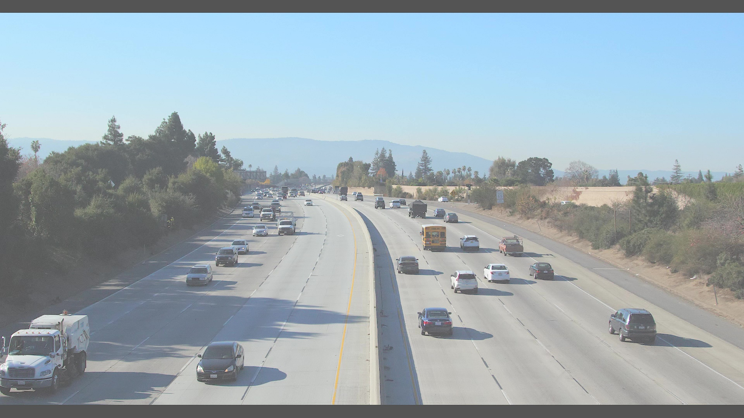

Tuning the parameters to suit the dataset.

Parameters VS Output frame

|  |  |
| --- | --- |
| **Parameters** | **Output Frame with Labels** |
| **max_boxes=10,**  **score_threshold=.6,**  **iou_threshold=.5**  **Only Few Vehicles**  **Next we decreasing Intersection Over Union and Score Threshold** |  |
| **max_boxes=30,**  **score_threshold=.2,**  **iou_threshold=.1**  **Most of the vehicles close to the POV are detected** |  |
| As the vehicles far from the Point Of View are **relatively very small** it is hard to detect both the near (big) and far (small) objects at the same time.  That is the probability to defining their class is low. So trying to decrease the score_threshold | |
| **max_boxes=30,**  **score_threshold=.01,**  **iou_threshold=.1**  **Most of the visibly big vehicles and even the persons inside them are detected**  **Even though the scores are quite low, the detection of the class is high as the object classes are diverse eg (car, bike, person, truck, plane etc .,.)**  **But we can a group of cars are detected as one with 0.04 confidence** |  |
| **As the 2 thresholds are set very low it is suspected to be error prone.**  **Hence the 2nd setting appears to be both without errors and detecting all objects in the close field of view of the camera** | |